MANAGEMENT BRIEF

**Growth of Stonecats (*Noturus flavus*) from two Lake Champlain tributaries**

**Elizabeth A. Puchala**

*Vermont Cooperative Fish and Wildlife Research Unit, Rubenstein School of Environment and Natural Resources, University of Vermont, Burlington, VT 05405, USA*

[*Betsy.puchala@gmail.com*](mailto:Betsy.puchala@gmail.com)

**Donna L. Parrish**

*U.S. Geological Survey, Vermont Cooperative Fish and Wildlife Research Unit, Rubenstein School of Environment and Natural Resources, University of Vermont, Burlington, VT 05405, USA*

**Derek H. Ogle**

*Department of Mathematical Sciences & Natural Resources, Northland College, Ashland, WI 54806, USA*

"This draft manuscript is distributed solely for purposes of scientific peer review. Its content is deliberative and predecisional, so it must not be disclosed or released by reviewers. Because the manuscript has not yet been approved for publication by the U.S. Geological Survey (USGS), it does not represent any official USGS finding or policy."

***ABSTRACT***

Little is known about Stonecat (*Noturus flavus*) populations, especially in the Northeastern United States, where these madtoms are at the edge of their range. In Lake Champlain tributaries, Stonecats are listed as endangered in Vermont, but not in New York. Here we describe the growth of Stonecats in two tributaries to Lake Champlain. We also compare the growth of Stonecats in these waters to results from other locations near the middle of their distribution. Stonecats in the Great Chazy River, NY were larger at age 0 and age 1 while those from the LaPlatte River, VT were larger at age 4 and age 5. Stonecats in Lake Champlain were generally larger at age than those from the middle of their range except for those from Lake Erie. We found that Stonecats from Lake Champlain exhibit growth patterns to reach maturity by age 3, an important consideration for management agencies in the Lake Champlain basin.

Stonecats (*Noturus flavus*) are widely distributed in the interior of North America, with populations in Vermont at the far northeastern edge of their range (Becker 1983). In 1994, the Vermont Agency of Natural Resources listed the Stonecat as endangered because its known distribution within the state is limited to two tributaries of Lake Champlain: the LaPlatte and Missisquoi rivers (Langdon et al. 2006). There is concern over the continued survival of these populations of Stonecats, especially given recent evidence for a slightly decreasing population size (Puchala et al. 2016).

Quist and Isermann (2017) stated that “age and growth investigations are critical for providing information on the basic ecology of a species and guiding management and conservation actions.” This is especially important for species of conservation concern that are often understudied because they are frequently imperiled (Burr and Stoeckel 2000). We are aware of only five studies, none of which were from the Lake Champlain drainage that examined growth of Stonecats (Gilbert 1953; Carlson 1966; Paruch 1979; Walsh and Burr 1985; Tzilkowski and Stauffer 2004). The utility of these studies for better understanding the dynamics of Stonecats in Lake Champlain is limited because these studies are quite dated, were primarily from populations near the middle of the distribution of Stonecats, and were based on a small sample size, varied methods to estimate age (e.g., pectoral spines, dorsal spines, and vertebrae), and specimens combined across multiple populations.

Our primary objective is to describe the growth of Stonecats in the LaPlatte River. Secondarily, we compare these results to results from other Stonecat populations to better understand the growth dynamics of LaPlatte River Stonecats. To augment previously published results, we also describe the growth of Stonecats from the Great Chazy River, which is a tributary to the New York side of Lake Champlain. Inclusion of these results allows us to compare the LaPlatte River results to a contemporary population in the same watershed. Our results, along with estimates of survival and population change provided by Puchala et al. (2016), will be an important consideration in the continued management of Lake Champlain Stonecat populations for long-term stability. In addition, our results contribute significantly to the literature that lacks information about the growth of this species, especially throughout its range.

**METHODS**

*Study sites*.—Stonecats were collected from two Lake Champlain tributaries. The Great Chazy River which originates near Ellenburg, New York, and empties into northern Lake Champlain (44.93236N; 73.38537W) is approximately 86 km long and drains a watershed of 790 km2. The LaPlatte River is 24-km long, drains a 138 km2 watershed (Pelton et al. 1998), and enters Lake Champlain in Shelburne Bay, Vermont (44.39959N; 73.23385W).

*Data Collection*.—Stonecats were collected from the lower 33 km of the Great Chazy River on 17-19 October 2012 as mortalities from a 3-trifluoromethyl-4-nitrophenol (TFM) lampricide treatment conducted on 16-18 October 2012. During the post-treatment assessment, teams of two biologists each scanned the banks, shallows, and other portions of the river where the bottom was visible to collect non-target mortalities. Additional specimens were collected from the Great Chazy River on 8-9 August 2011 and 15 November 2011, NY as part of a bioassay study (Calloway 2012). Stonecats were frozen as quickly as possible and returned to the lab where they were thawed and measured for standard (SL) and total lengths (TL) to the nearest mm before the dorsal spine was removed by cutting it just above the articulation point (Buckmeier et al. 2002; Manny et al. 2014; Fischer and Koch 2017).

Spines were placed in boiling water to remove excess skin and flesh and then allowed to dry before being set in epoxy. One or two 0.5-mm sections were cut from the spine using a BuehlerTM low-speed isomet saw (Buehler, Lake Bluff, Illinois). Thin sections were glued to slides for viewing under an Olympus SZX9TM dissecting microscope using fiber optic transmitted light. Three readers blind to fish size independently estimated age by identifying annuli in the patterns of translucent and opaque zones of the sectioned spine. The three readers attempted to reach a consensus age if there were discrepancies among their estimated ages. If a consensus could not be reached then the fish was removed from further analysis.

Stonecats were collected from the LaPlatte River from June to October 2012, May to October 2013, and June to October 2014 using backpack electrofishing and minnow traps. Backpack electrofishing generally used 200 volts, 20-30 Hz, and a 20-40% duty cycle and, because Stonecats are nocturnal, began no earlier than 0.5 h after sunset. Electrofishing effort depended on the length of stream section and ranged from 26 to 247 minutes, with a mean effort of 86 minutes (SD = 49.4). Minnow traps were 42 cm long and 23 cm diameter with 2.5 cm openings at each end and 0.6 cm square meshed sides. Minnow traps were set overnight (18-24 h soak time) in gangs of three or four attached to a single weight. Further sampling details are in Puchala et al. (2016).

Captured Stonecats not experiencing obvious distress were anesthetized in a 100 mg/L concentration of tricaine methanesulfonate (MS-222). Each individual was measured for TL to the nearest mm and all Stonecats approximately 90 mm TL and greater had a passive integrated transponder (PIT) tag (134-kHz, 8.4 x 1.4 mm; Biomark, Boise, Idaho) inserted into the peritoneal cavity through a 2-mm incision in the upper abdominal wall. The slit was then treated with iodine. Individuals were examined for the presence of a PIT tag after the first sampling event. Spines were not removed from these fish to minimize the traumatic impact of removal on other aspects of our overall study (Puchala et al. 2016).

*Data analysis.*— Growth of Stonecats collected from the Great Chazy River was summarized with the traditional von Bertalanffy growth function (VBGF; Beverton and Holt 1957):

$$L_{t}=L_{∞}\left(1-e^{-K\left(t-t_{0}\right)}\right)$$

where *Lt* is the observed TL at time (or age) *t*, *L*∞ is the asymptotic mean TL, *K* is the Brody growth coefficient, and *t0* is the theoretical time when the mean TL is zero (Ogle et al. 2017). We used fractional ages in this model to adjust for our fish being collected at various times throughout the growing season (Ogle et al. 2017). We assumed that annual growth on the spine commenced on June 1 (Carlson 1966) and was completed by November 1. Thus, the adjusted age was equal to the number of observed annuli for fish collected before June 1, was one more than the number of observed annuli for fish collected after November 1, and was the number of observed annuli plus the fraction of the growing season completed for fish captured between June 1 and November 1. We chose not to use a growth function with a seasonal component (e.g., Somers 1988) for fish collected from the Great Chazy River because sampling dates were concentrated on only a few days in a year.

Growth of Stonecats collected from the LaPlatte River could not be summarized with the traditional VBGF because age for these fish could not be estimated. Rather we summarized growth of Stonecats from the LaPlatte River with the traditional VBGF modified by Francis (1988) for use with mark-recapture data and including a seasonal component:

$$ΔL=\left(\frac{{L_{2}g}_{1}-{L_{1}g}_{2}}{g_{1}-g_{2}}-L_{m}\right)\left(1-{\left[1+\frac{g_{1}-g_{2}}{L_{1}-L_{2}}\right]}^{ΔT+θ_{2}-θ_{1}}\right)$$

where

$$θ_{i}=\frac{u\sin\left(2π\left(t_{i}-w\right)\right)}{2π}$$

Here, *Lm* is the TL at time of marking, *ΔL* is the change in TL between marking and recapture, *t1* and *t2* are the marking and recapture times (years), *Δ t* is the change in time (years) between marking and recapture, *g1* and *g2* are parameters that represent the mean annual growth rate or increment at *L1* and *L2* (which are chosen by the analyst), *w* is a parameter that represents the time of year when the growth rate is maximum, and *u* is a parameter that describes the extent of the seasonal variation in growth (i.e., *u*=0 represents no seasonal variability in growth). For fish that were recaptured multiple times, we treated each interval between recaptures as independent capture-recapture (C-R) events (Ogle 2017). For example, if a fish was captured three times, we considered the interval from marking to the first recapture as one C-R observation and the interval from the first to second recapture as a separate C-R observation. Capture-recapture events based on observations within 7 d of each other were excluded from further analysis under the assumption that any growth that occurred in this short period was minimal and likely less than measurement error. We modeled a season component to growth with these data because fish were collected on many dates within each year, rather than on only a few dates as with the Great Chazy River data.

Both growth models were fit with the nls() function in R v3.5.1 (R Core Team 2018) using the “port” algorithm. The *g1*, *g2*, and *u* parameters were constrained to be positive and the *w* parameter was constrained to be between 0 and 1. All other parameters were unconstrained in model fitting. Three different starting values and two other algorithms (Gauss-Newton in the nls() function and Levenburg-Marquardt in the nlsLM() function from the minpack.lm package v1.2-1 [Elzhov et al. 2016]) were used to determine the robustness of parameter estimates to staring values and model fitting algorithms (Ogle et al. 2017). Bootstrap confidence intervals for model parameters were estimated from 999 bootstrapped samples using the nlsBoot() function from the nlsTools package v1.0-2 (Baty et al. 2015) as described in Ogle (2016).

Parameter estimates could not be compared between the two locations because different models were required for each location. Thus, we compared growth between locations by predicting mean lengths at age. Mean lengths-at-age are predicted directly from the traditional VBGF for Great Chazy River Stonecats. However, the Francis model does not use age as a variable and, thus, mean lengths-at-age cannot be predicted directly. In this case, we estimated the mean length at age 1 from the length frequency histogram of all Stonecats captured in the LaPlatte River during early summer. We then used the results from the Francis model to predict the annual growth increment for fish of this length. The predicted annual growth increment was added to the mean length at age 1 to predict the mean length at age 2. This process was repeated until mean lengths for all ages up to age 6 had been predicted. We also compared predicted mean lengths-at-age for Stonecats from the LaPlatte and Great Chazy rivers to mean lengths-at-age reported for Stonecats in the literature (Gilbert 1953; Carlson 1966; Paruch 1979). Some of the literature results were converted from SL to TL using results from a linear model fit to our measurements of SL and TL on fish collected from the Great Chazy River.

**RESULTS**

A total of 183 Stonecats from the Great Chazy River were aged from spines. Of these, six (3%) were removed from further analysis because the three readers could not agree on a consensus age. Age-classes ranged from 0 (young-of-the-year) to 5 with most fish age 0 (49%) and only five fish (3%) age 4 or older. Stonecats from the Great Chazy River ranged from 44 to 193 mm TL, with a mean TL of 114 (SD = 41.5) mm. The SL-TL relationship was TL=1.239+1.166SL (r2 = 0.996). Parameter estimates (with 95% confidence intervals) from fitting the traditional VBGF to the Great Chazy River Stonecats are 172 (160 - 193) for *L*∞, 0.79 (0.52 - 1.16) for *K*, and 0.13 (-0.15 – 0.34) for *t0* (Figure 1).

A total of 1311 Stonecats were PIT tagged in the LaPlatte River. These fish ranged in length from 28 to 205 mm, with a mean of 124 (SD = 31) mm. Our gears collected few fish under 90 mm, but a separate mode of small fish in May 2013 and the lower mode of a bimodal distribution in June 2012 suggested that age-1 fish started the growing season at approximately 70-80 mm TL.

Of the 133 (10%) Stonecats were recaptured at least once from the LaPlatte River, 111 fish (83%) were recaptured once, 20 fish (15%) were recaptured twice, and 2 fish (2%) were captured three times. Thus, 157 paired C-R events were observed, though 9 (6%) of these were within 7 days of each other and were removed from further analysis. Of the remaining C-R events, 61% of recaptures were in the same year as the original capture, 39% were in the following year, and 1% were two years later (Figure 3). Stonecats recaptured from the LaPlatte River ranged from 87 to 185 mm TL at the time of marking, with a mean of 131 (SD = 20.5) mm. One fish was 192 mm at the time of recapture. Parameter estimates (with 95% confidence intervals) from fitting the modified VBGF to the LaPlatte River Stonecats are 34.1 (32.6 – 35.8) for *g1* at *L1*=100, 18.0 (16.6 – 19.4) for *g2* at *L2*=150, 0.55 (0.52 – 0.58) for *w*, and 2.52 (2.27 – 2.87) for *u*. Estimated mean lengths of LaPlatte River Stonecats at ages 1 to 6 estimated from the VBGF model fit and assuming a mean length at age 1 of 75 mm are shown in Figure 4.

**DISCUSSION**

Stonecats from the Great Chazy River were slightly larger than those from the LaPlatte River for the first three years of life, after which their lengths were similar Stonecats from the Lake Champlain tributaries were approximately the same size as Stonecats from Lake Erie at age 1, but substantially smaller for the LaPlatte River fish by age 2 and fish from both tributaries after age 2. Stonecats from the Lake Champlain tributaries are longer at all ages for other populations of Stonecats reported in the literature. Thus, Stonecats in the Lake Champlain tributaries, at the northeast margin of their distributional range, may grow faster that Stonecats from streams in the middle part of their distribution, but not from those in Lake Erie. Gilbert (1953) suggested that Lake Erie Stonecats may exhibit exceptional growth because of the availability of mayfly nymphs as prey.

We found it difficult to identify annuli, especially near the central lumen, on sectioned spines from the Great Chazy River fish. Other authors have noted similar difficulties. Gilbert (1953) commented on difficulties identifying the first annulus on Stonecat vertebrae and Tzilkowski and Stauffer, Jr. (2004) noted that annular rings were often not discernible on Stonecat pectoral spines. Given the similar growth curves between the Great Chazy River Stonecats (derived from spines) and the LaPlatte River (derived independent of any calcified structure) we feel that our age estimates from spines are reasonable. Similarly, our growth estimates from capture-recapture data appear reasonable, demonstrating a method to assess growth for species, such as endangered Vermont Stonecats, where calcified structures cannot be collected. Nevertheless, future Stonecat age and growth studies would benefit from understanding the precision and accuracy (i.e., validity) of various methods for assessing the age of Stonecats.

These results contribute to a better understanding of the general growth dynamics of Stonecats. However, they are also immediately relevant to management of fish populations in these Lake Champlain tributaries. The LaPlatte River was first treated with TFM in 2016, two years after our last sample, to control larval Sea Lamprey (*Petromyzon marinus*) numbers. Bioassay results on Stonecats between 122 and 200 mm TLindicated that 10% mortality could occur at a TFM concentration of 1.2 times that needed to kill 99% of the larval Sea Lamprey present (Calloway 2012). The predominance of age-0 fish in our Great Chazy River samples, which largely came from mortalities collected following a TFM treatments, suggests that this mortality may target young-of-the-year fish. Tributaries are treated with TFM on a rotating basis every four or more years, which could pose a problem for Stonecat populations if most fish mature after age-4. In Pennsylvania, female Stonecats matured at 102-141 mm SL, or 120-166 mm TL (Tzilkowski and Stauffer, Jr. 2004). These lengths correspond to age-2 to age-4 Stonecats in the LaPlatte River. Thus, most female Stonecats in the LaPlatte River would mature within the minimum TFM treatment interval.

**ACKNOWLEDGMENTS**

We thank Vermont biologists, Ken Cox (Project Officer) and Bernie Pientka, for their guidance and participation throughout the project; M. Stein, L. Simard, A. Sotola and other technicians and volunteers who assisted in the field and lab. Funding was from the Vermont Fish and Wildlife State Wildlife Grants Program. The views expressed here are those of the authors and do not necessarily reflect the views of the sponsors. Any use of trade, firm, or product names is for descriptive purposes only and does not imply endorsement by the U.S. Government. This study was performed under the auspices of the University of Vermont IACUC Protocol #12-005 and a Vermont Agency of Natural Resources’ Endangered & Threatened Species Takings Permit (permittee Ken Cox). The Vermont Cooperative Fish and Wildlife Research Unit is jointly supported by the U.S. Geological Survey, Vermont Department of Fish and Wildlife, University of Vermont, and the Wildlife Management Institute.

**REFERENCES**

Baty, F., C. Ritz, S. Charles, M. Brutsche, J. P. Flandrois, and M. L. Delignette-Muller. 2015. A toolbox for nonlinear regression in R: the package nlstools. Journal of Statistical Software 66(5):1-21.

Becker, G. C. 1983. Fishes of Wisconsin. University of Wisconsin Press, Madison, Wisconsin.

Beverton, R. J. H., and S. J. Holt. 1957. On the dynamics of exploited fish populations. United Kingdom Ministry of Agriculture; Fisheries.

Buckmeier, D. L., E. R. Irwin, R. K. Betsill, and J. A. Prentice. 2002. Validity of otoliths and pectoral spines for estimating ages of Channel Catfish. North American Journal of Fisheries Management 22: 934-942.

Burr, B. M., and J. N. Stoeckel. 2000. The natural history of madtoms (genus Noturus), North America's diminutive catfishes. Pages 51-101 in E. R. Irwin, W. A. Hubert, C. F. Rabeni, H. L. Schramm, Jr., and T. Coon, editors. Catfish 2000: Proceedings of the international ictalurid symposium. American Fisheries Society, Symposium 24, Bethesda, Maryland.

Calloway, M.T. 2012. Report on Stonecat toxicity after exposure to TFM (lampricide). U. S. Fish and Wildlife Service, Lake Champlain Fisheries Resource Office, Essex Junction, Vermont.

Carlson, D. R. 1966. Age and growth of the stonecat, *Noturus flavus* Rafinesque, in the Vermillion River. Proceedings of the South Dakota Academy of Sciences 45:131-137.

Carlson, D. M., R. A. Daniels, and J. J. Wright. 2016. Atlas of inland fishes of New York. New York State Museum Record 7, New York State Education Department and Department of Environmental Conservation, Albany, New York.

Elzhov, T. V., K. M. Mullen, A.-N. Spiess, and B. Bolker. 2015. minpack.lm: R interface to the Levenberg-Marquardt nonlinear least-squares algorithm found in MINPACK, plus support for bounds. R package.

Fischer, J. R., and J. D. Koch. 2017. Fin rays and spines. Pages 173-187 *in* M. C. Quist and D. A. Isermann, editors. Age and growth of fishes: principles and techniques. American Fisheries Society, Bethesda, Maryland.

Francis, R. I. C. C. 1988. Maximum likelihood estimation of growth and growth variability from tagging data. New Zealand Journal of Marine and Freshwater Research 22:42-51.

Gilbert, C. R. 1953. Age and growth of the yellow stone catfish *Noturus flavus* (Rafinesque). Master’s thesis. The Ohio State University, Columbus, Ohio.

Langdon, R. W., M. T. Ferguson, and K. M. Cox. 2006. Fishes of Vermont. Vermont Department of Fish and Wildlife, Waterbury, Vermont.

Manny, B. A., B. A. Daley, J. Boase, A. N. Horne, and J. Chiotti. 2014. Occurrence, habitat, and movements of the endangered northern madtom (*Noturus stigmosus*) in the Detroit River, 2003–2011. Journal of Great Lakes Research 40 (Supplement 2): 118-124.

Ogle, D. H. 2016. Introductory fisheries analysis with R. Chapman & Hall/CRC Press, Boca Raton, Florida.

Ogle, D. H., T. O. Brendan, and J. L. McCormick. 2017. Growth estimation: growth models and statistical inference. Pages 265-359 *in* M. C. Quist and D. A. Isermann, editors. Age and growth of fishes: principles and techniques. American Fisheries Society, Bethesda, Maryland.

Paruch, W. 1979. Age and growth of Ictaluridae in Wisconsin. Master’s thesis. University of Wisconsin, Stevens Point, Wisconsin.

Pelton, D. K., S. N. Levine, and M. Braner. 1998. Measurements of phosphorus uptake by macrophytes and epiphytes from the LaPlatte River (VT) using 32P in stream microcosms. Freshwater Biology 39:285-299.

Puchala, E. A., D. L. Parrish, T. M. Donovan. 2016. Predicting the stability of endangered Stonecats (*Noturus flavus*) in the LaPlatte River, Vermont. Transactions of the American Fisheries Society 145: 903-912.

Quist, M. C., and D. A. Isermann. Age and growth of fishes: principles and techniques. American Fisheries Society, Bethesda, Maryland.

R Development Core Team. 2017. R: a language and environment for statistical computing. R Foundation for Statistical Computing. Vienna, Austria. URL <http://R-project.org>.

Somers, I. F. 1988. On a seasonally oscillating growth function. Fishbyte 6:8-11.

Tzilkowski, C. J., and J. R. Stauffer, Jr. 2004. Biology and diet of the northern madtom (*Noturus stigmosus*) and stonecat (*Noturus flavus*) in French Creek, Pennsylvania. Journal of the Pennsylvania Academy of Science 78: 3-11.

Walsh, S. J., and B. M. Burr. 1985. Biology of the Stonecat, *Noturus flavus* (Siluriformes, Ictaluridae), in central Illinois and Missouri streams, and comparison with Great Lakes populations and congeners. Ohio Journal of Science 85:85-96.

**Figure headings**

Figure 1. Fit (solid line), with 95% confidence bounds (dashed lines), of the traditional von Bertalanffy growth function to total lengths and ages estimated from spines of Stonecats collected from the Great Chazy River, New York in 2011 and 2012. Ages have been adjusted to represent the number of observed annuli on the spine plus the fraction of growth completed in the year the fish were collected. Observations are plotted with a semi-transparent color such that darker points represent more observations.

Figure 2. Histogram of times-at-large for Stonecats captured and recaptured from the LaPlatte River, Vermont in 2012-2014. Each bar in the histogram is fourteen days wide. Note that nine capture-recapture events where the time between capture and recapture was less than seven days are not included.

Figure 3. Histograms of total length of Stonecats captured in the LaPlatte River during May, June, and July of 2012, 2013, and 2014. Note that no sampling occurred in May 2012, June 2013, or May 2014.

Figure 4. Annual total length increment versus initial total length for the two locations of this study (Great Chazy and LaPlatte rivers) and for four previous studies (Lake Erie (Gilbert 1953), Wisconsin streams (Paruch 1979), Vermillion River (Carlson 1966), and Ohio streams (Gilbert 1953). The LaPlatte River results are shown with 95% bootstrap confidence intervals for the annual increment obtained from parameters in the von Bertalanffy growth function modified by Francis (1988). The Great Chazy River results show 95% bootstrap confidence intervals for both the annual increment and the initial total length as predicted from the fit of the traditional von Bertalanffy growth function.

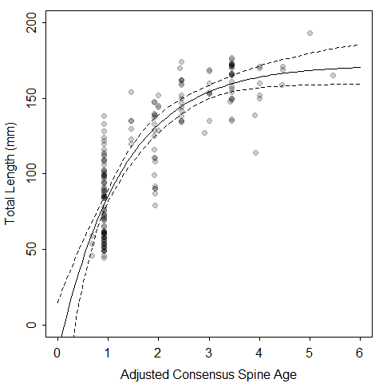

Figure 1.

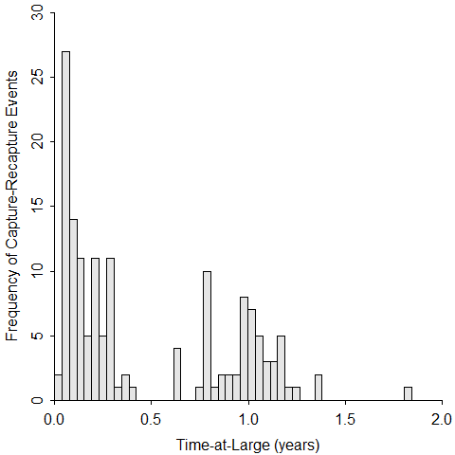

Figure 2.

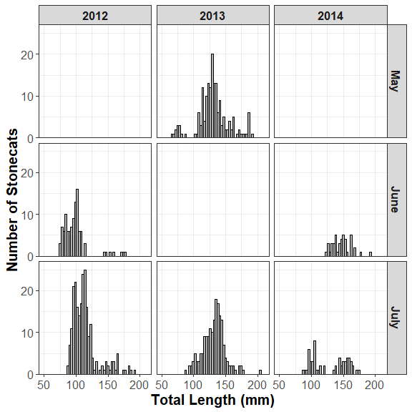

Figure 3.

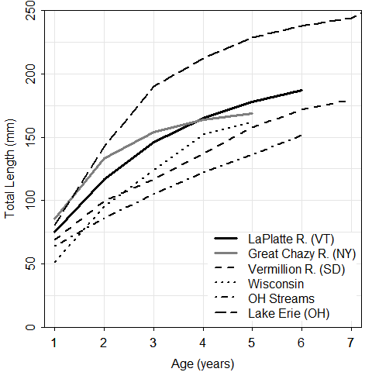

Figure 4.